**Summery of first results – MATLAB CSMA/CA simulator – WiFi project**

The simulator simulates the CSMA/CA mechanism of 802.11 protocol, which is aimed to avoid packets collision.

We research long-distance WiFi links. We want to make CSMA/CA work better on such links, by changing the protocol parameters – especially the SlotTime.

Some results from the simulator

Links with the standard SlotTime and with 2APD SlotTime were simulated. All of the simulations were 5 seconds simulation, with 1Mbps data rate and 6 Mbps PHY rate for each link.

NOTE: in the “meters” experiments, ignore the km scale in the horizontal axis!

**CBR – constant packet size (with randomness in the IAT):**

1460B packets:

1 pTp link, 10-100 meters:

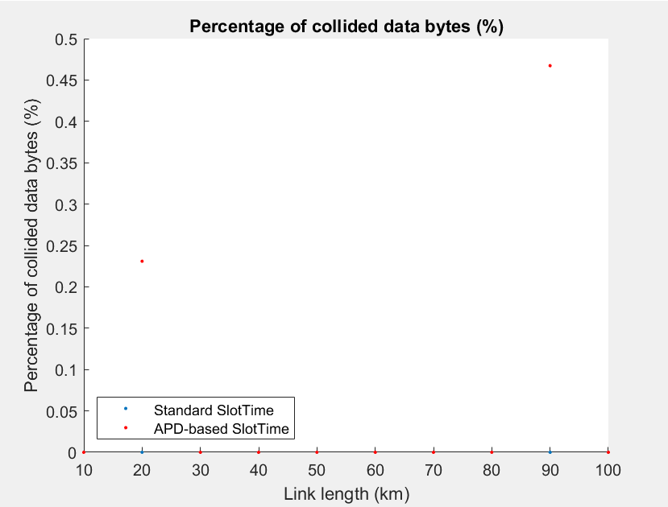

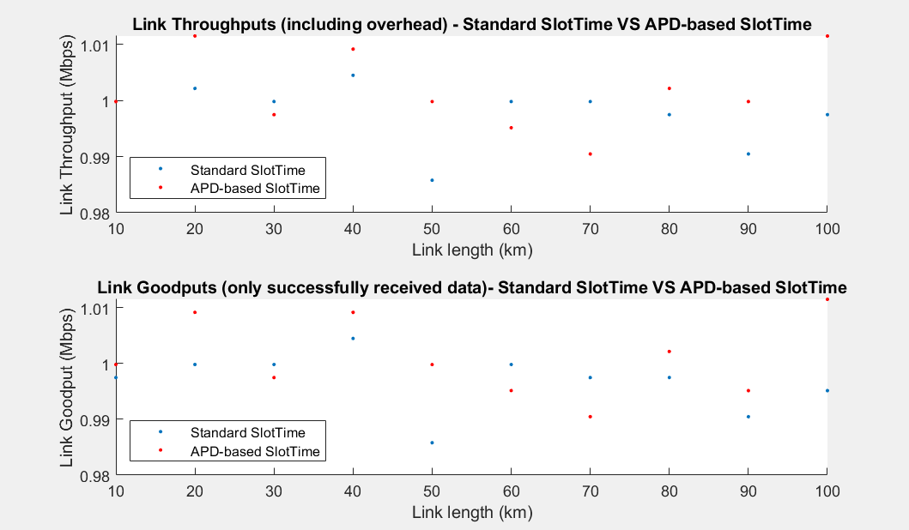

1 pTp link, 10-100 kms:

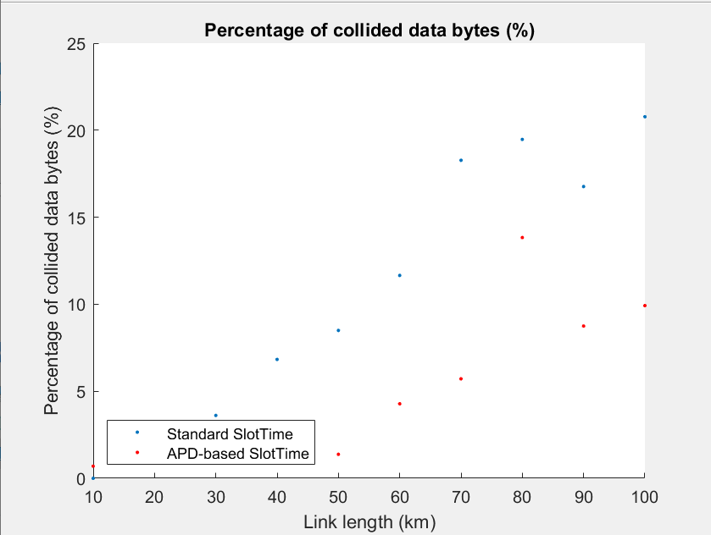

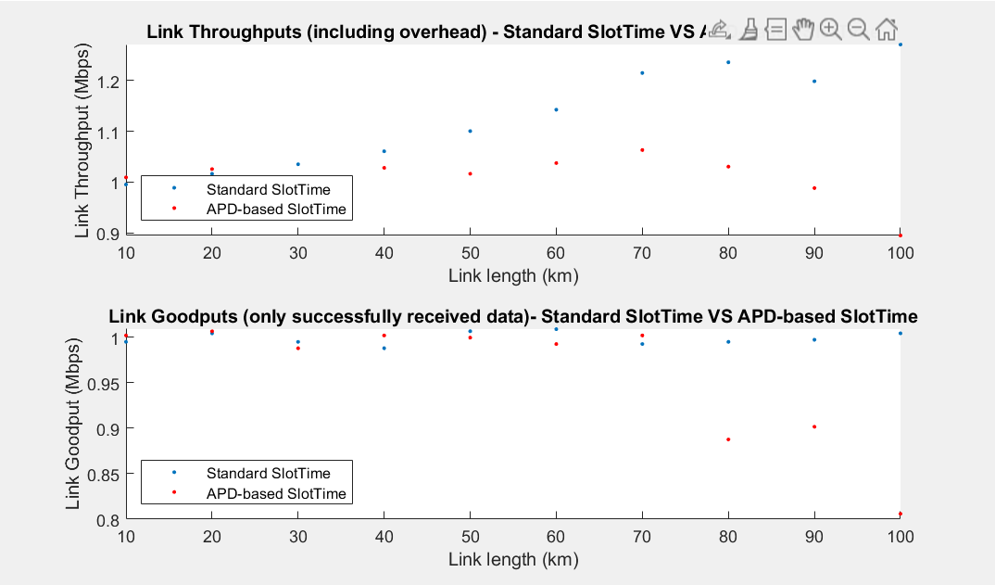

2 pTp links, 10-100 meters:

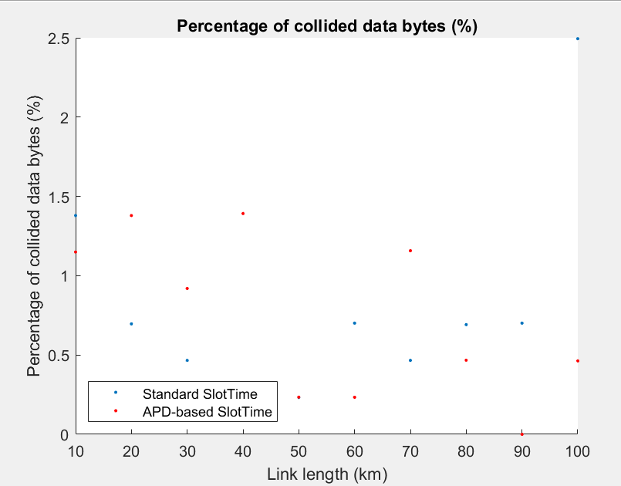

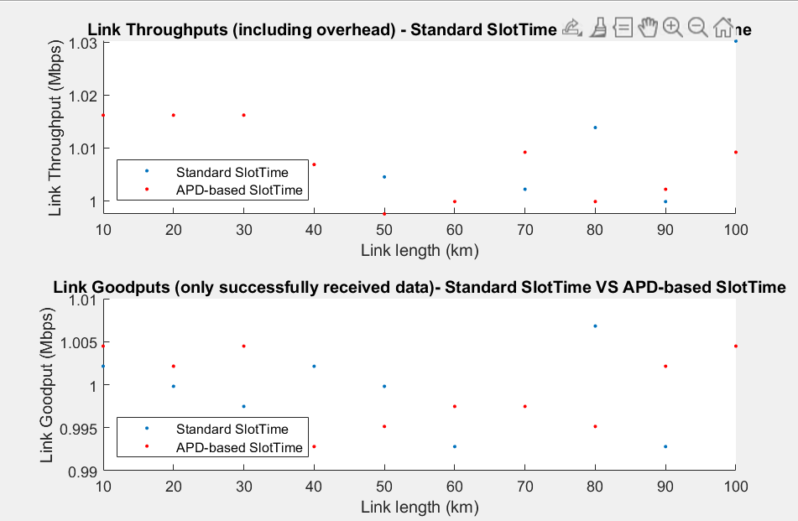

Another link:

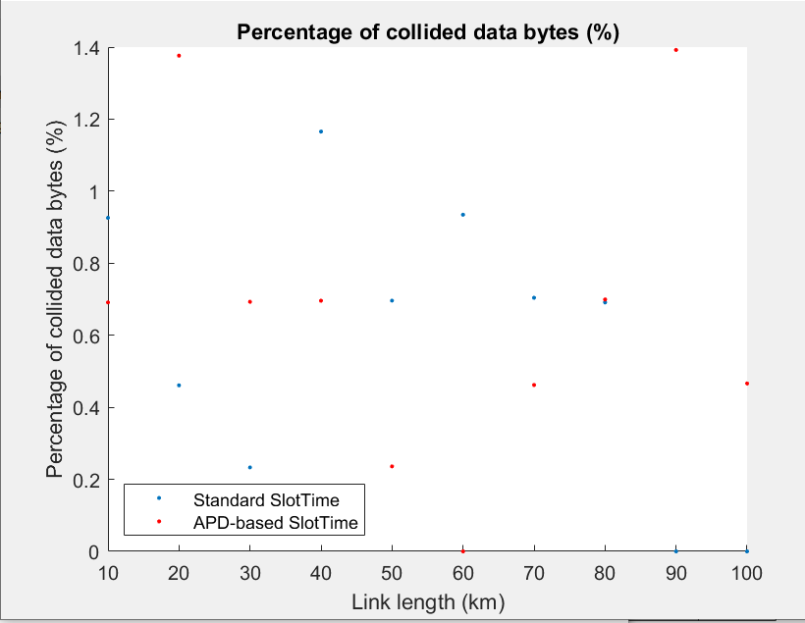

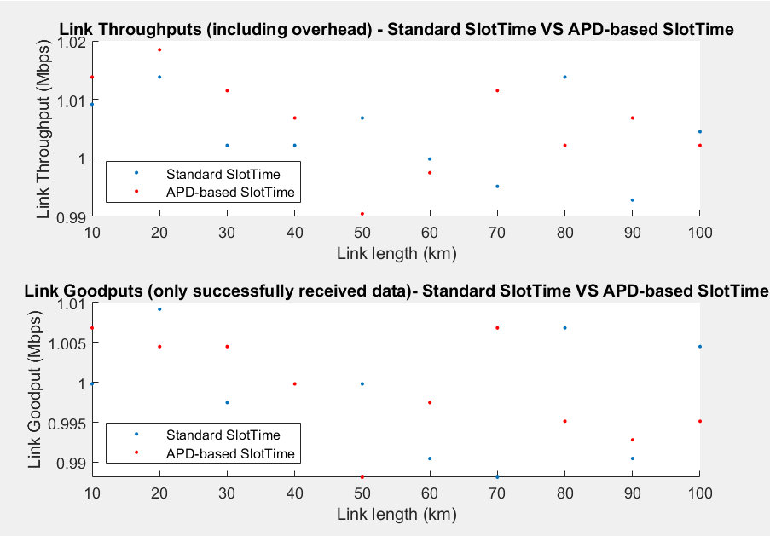

2 pTp links, 10-100 kms:

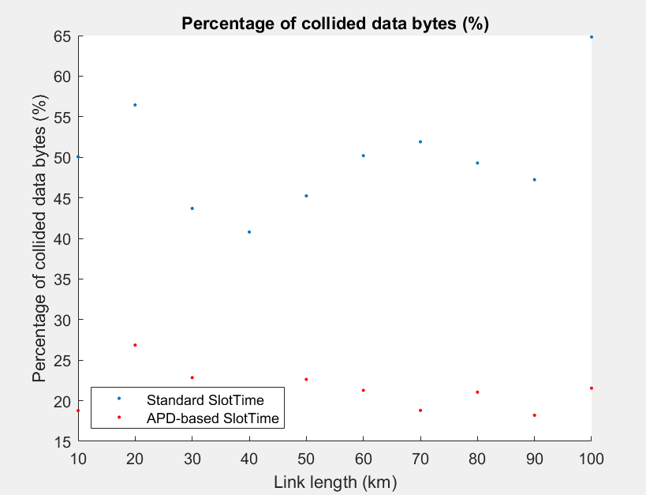

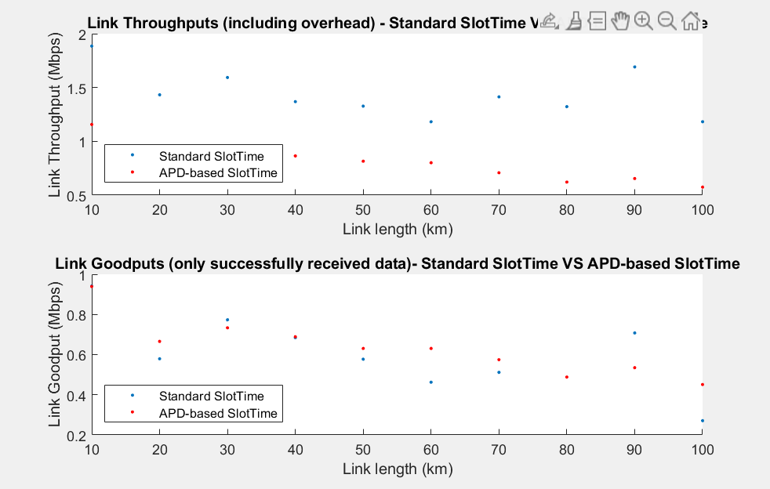

Another link:

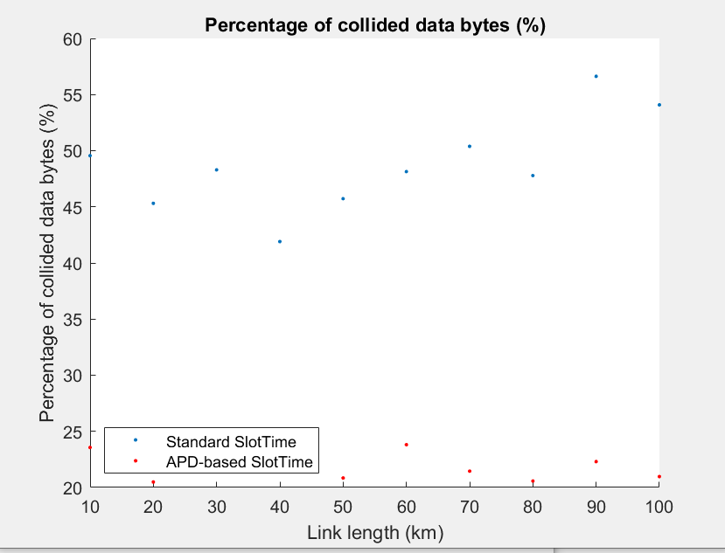

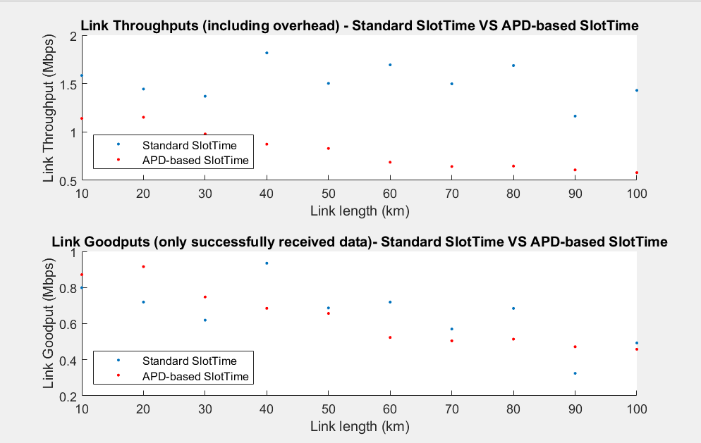

100B packets:

1 pTp link, 10-100 kms:

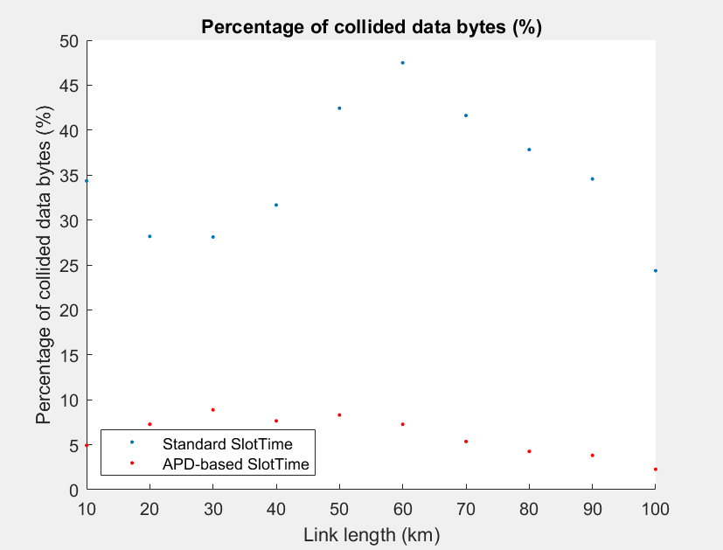

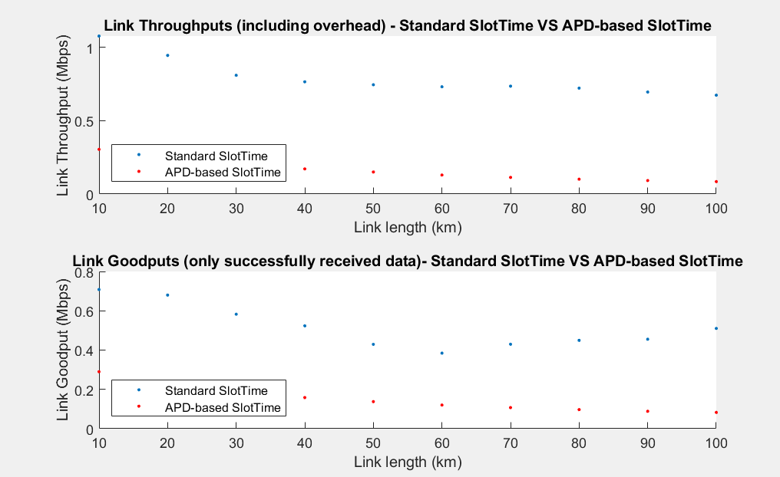

**Random Size packets – 100B-2000B:**

1 pTp link, 10-100 meters:

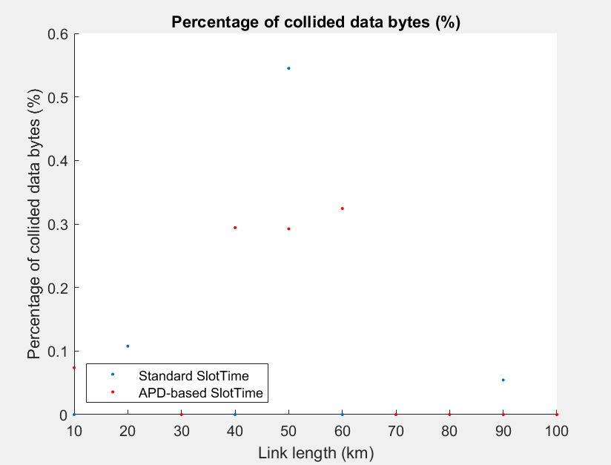

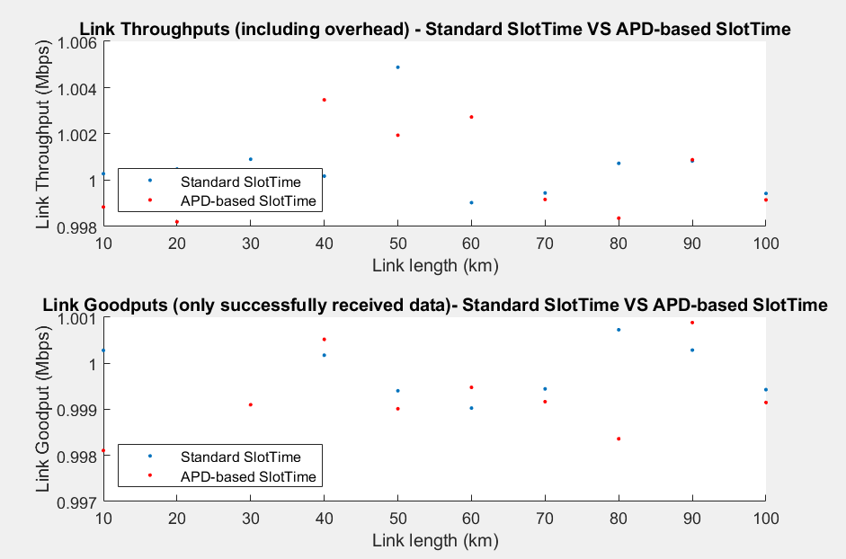

1 pTp link, 10-100 kms:

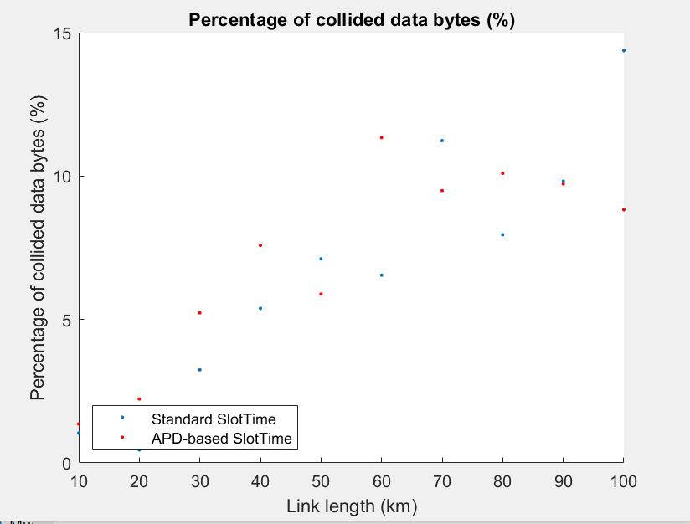

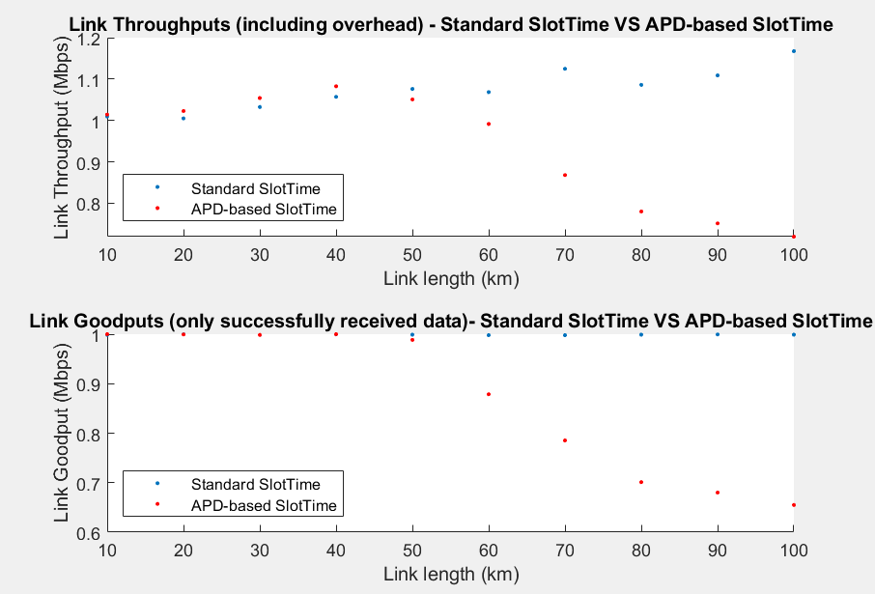

2 pTp links, 10-100 meters:

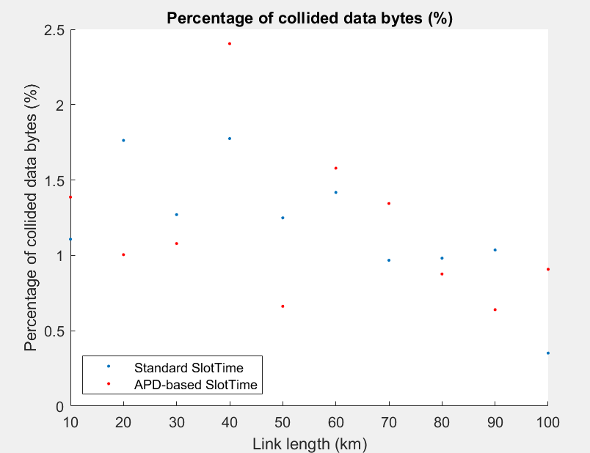

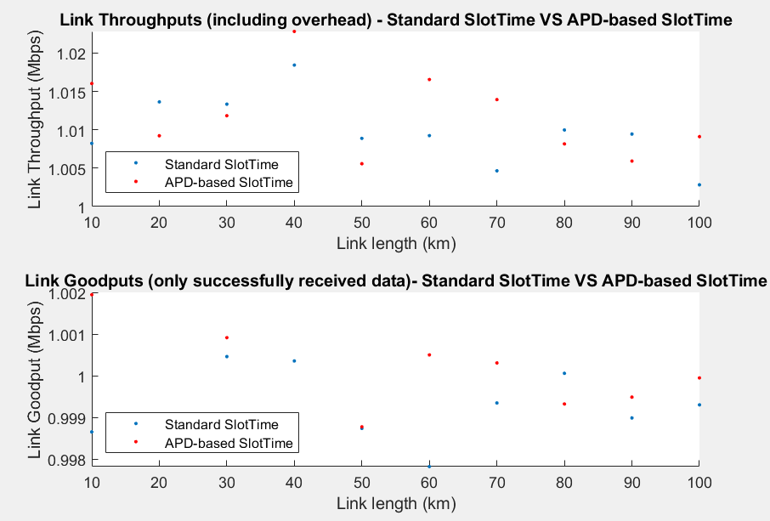

Another link:

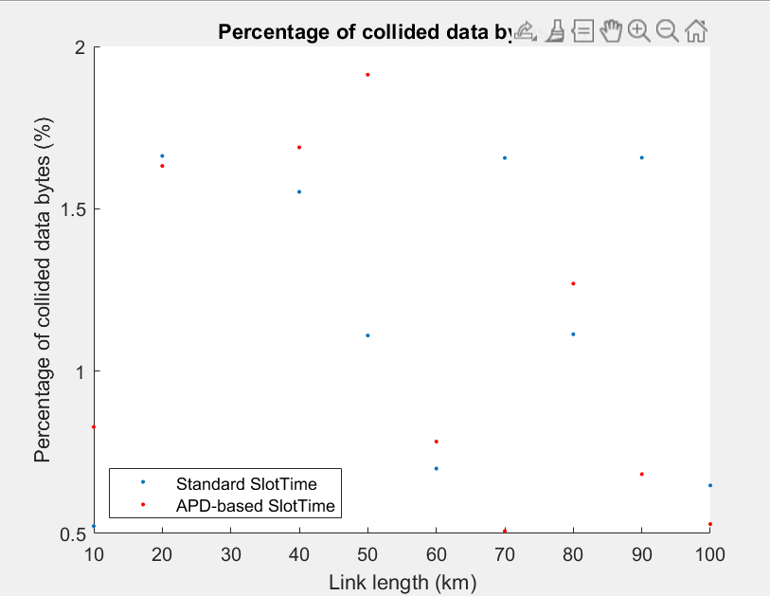

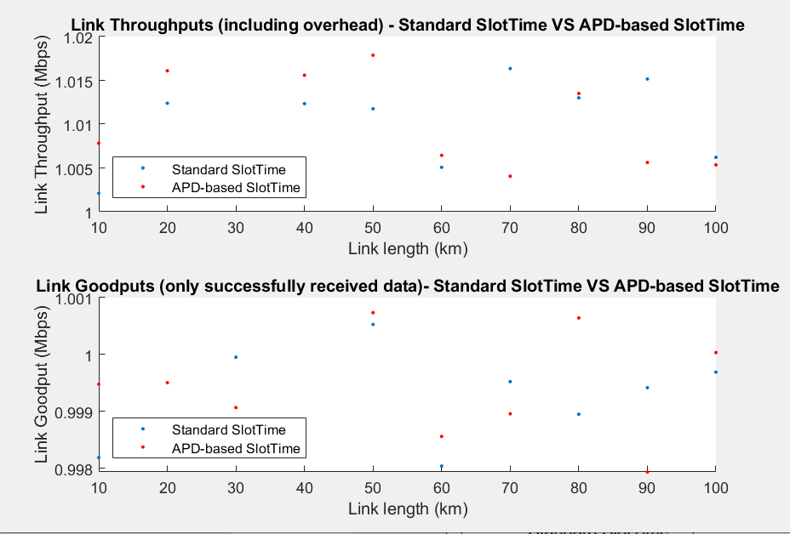

2 pTp links, 10-100 kms:

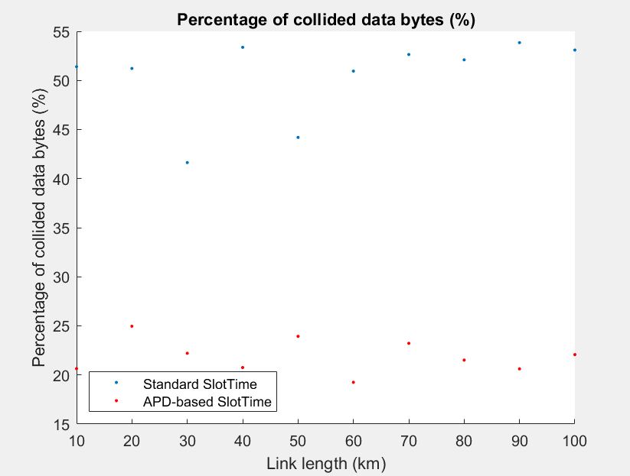

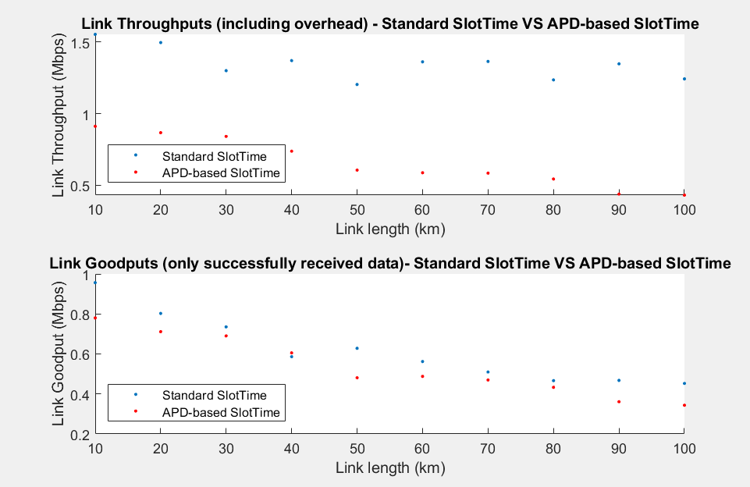

Another link:

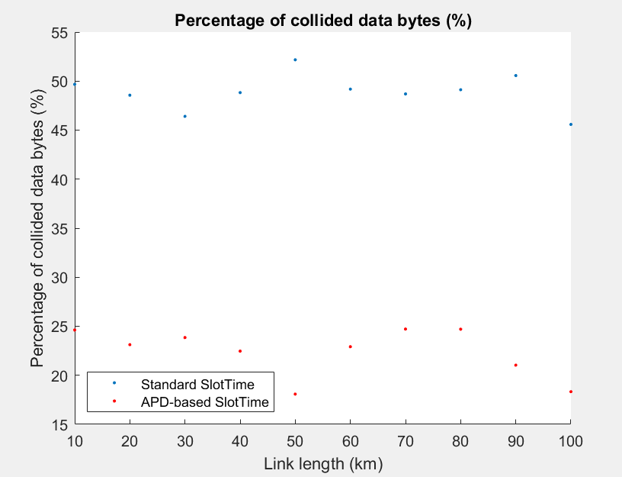

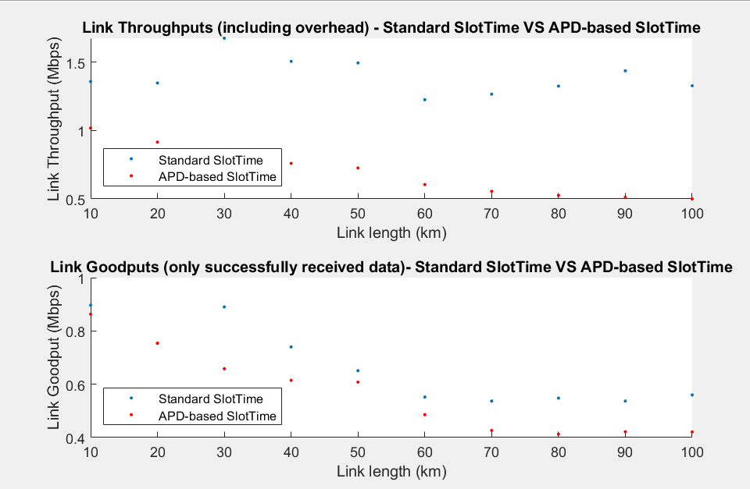

Various ST values on 1 pTp link, CBR 1460B packets:

